Important Safety Notice

Savaria and Garaventa Branded Residential Elevators (see below)

The U.S. Consumer Product Safety Commission, Savaria and Garaventa are recalling to inspect/repair the following products due to an industry-wide issue involving home elevators installed with an excessive space between the elevator swing landing door (also called hoistway or hallway door) and elevator car door or gate. Although there have been no entrapment incidents with our elevators, young children can become entrapped in that excessive space and suffer serious injuries or death. If there is an excessive space between the landing door and elevator car door at any landing, we will provide you with free space guards to eliminate the excessive space.

The following models are affected:

Certain Eclipse, Infinity, Kwiklift, MR, and HR units sold between 1999 and 2021. Model names are located on the elevators’ controllers.

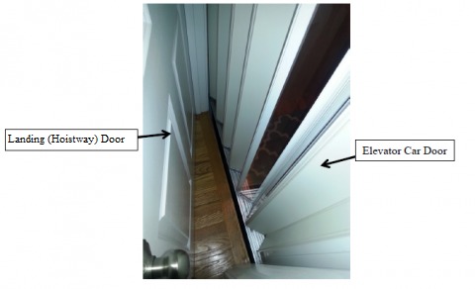

The above picture shows a Residential Elevator with Space Between the Exterior Swing Landing (Hoistway) Door and Interior Elevator Car (Accordion) Door. A young child can become entrapped if there is an excessive space between the doors.

If your elevator is affected, KEEP UNSUPERVISED YOUNG CHILDREN AWAY FROM IT, and call toll free for a free space guard and installation instructions.
1-855-983-5520
between 8 a.m. and 5 p.m., Eastern Time, Monday through Friday, or go to www.home-elevator-door-gap.com for information about obtaining free space guards.

